www.voevodathefilm.com
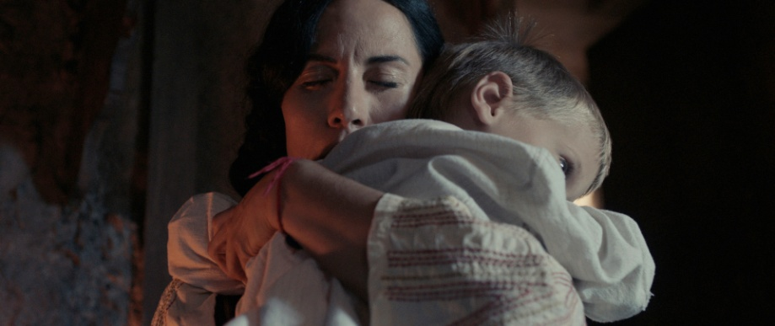

VOEVODA. PRESS KIT.

LOGLINE
A tortured mother leaves her child and home and leads a band of rebels inflicting her own justice, while struggling to make it up to the male world of 19th century.
SHORT SYNOPSIS
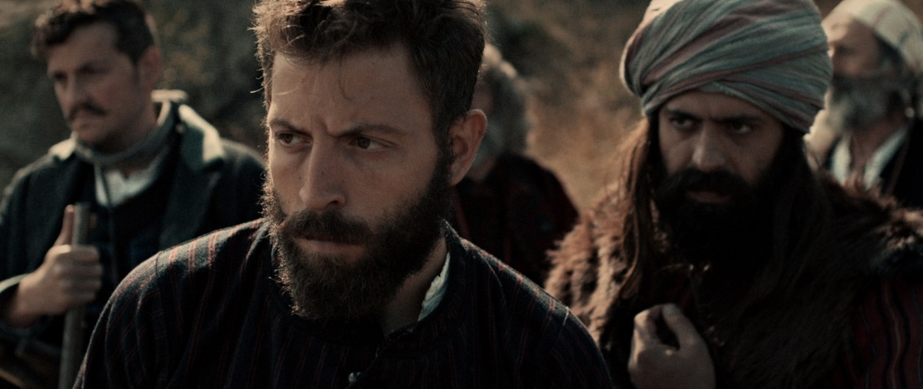
Roumena is a tortured mother forced to abandon her child and home, who leads a band of rebels and inflicts her own justice while struggling to make it up to the men’s world of 19th century. “Voevoda” means rebel-leader, commander, guardian and tells a true story, based on witness accounts.
DIRECTOR’S NOTES
The film features many nonprofessional actors, the writer/director/producer playing the lead role and her daughter playing the younger Roumena. Through rough and raw cinematic narrative the film strives for authenticity imposing the question how cruel humans are to the ones who are different. A woman ahead of her time, Roumena pushes relationships beyond the obvious religious, cultural and gender limits.
LONG SYNOPSIS
Voevoda (rebel-leader, commander, guardian) tells the true story of Roumena - a mother, forced to abandon her child and home, who leads a band of rebels and inflicts her own justice while struggling to make it up to the men’s world of 19th century Ottoman Empire. Based on witness accounts and a short story by Nikolay Haytov. The film features many nonprofessional actors, the writer/director/producer playing the lead role and her daughter playing the younger Roumena. Through rough and raw cinematic narrative the film strives for authenticity imposing the question how cruel humans are to the ones who are different.
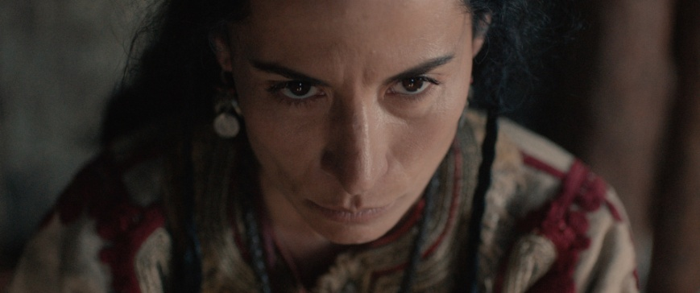

DIRECTOR’S CV SHORT

Zornitsa Sophia graduated as Master of Fine Arts, major in painting, later in Film Directing. Her first film is MILA FROM MARS, 16 awards, 60 festivals and a box office hit in Bulgaria. She wrote, directed and produced 3 feature films and 2 documentaries, directed 6 TV series and 1 awarded theater play. VOEVODA is her third feature film as writer, director and producer and first as actress, currently a national box office hit.

DIRECTOR’S CV LONG
Zornitsa Sophia is Master of Fine Arts, major in painting, specialized in School of Visual Arts, NYC and AU, DC. She exhibited in 65 visual arts events internationally and restored the church in Sofia Male Prison, together with the convicts. Her debut no budget feature "Mila From Mars" (2004) won 16 awards, including Best Film and Special Jury Award at Sarajevo IFF, Best Film, Best Actress and 3 more awards at “Golden Rose”, two awards at Mannheim-Heidelberg IFF, screened at 60 festivals including Mar del Plata, Pusan, Goa, New Directors/New, it was Bulgarian submission for Academy Awards and a box office hit nationally. Followed by "Death and All The Way Back" (docu, 2005), "Modus Vivendi" (docu, 2006), "Forecast" (feature, 2009). She directed 18 episodes in 6 TV series in all genres and one awarded theater play. "Voevoda" is Zornitsa Sophia’s third feature film as writer, director and producer and first as actress. It’s currently a national box office hit with World Premiere in Shanghai IFF and European Premiere in Moscow IFF.
FILMOGRAPHY
Mila From Mars, feature film, 2004
Death and All The Way Back, documentary, 2005
Modus Vivendi, documentary, 2006
Forecast, feature film, 2009
Voevoda, feature film, 2017
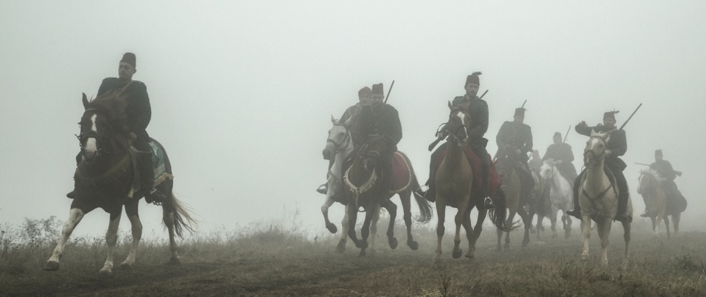

CREDITS
www.voevodathefilm.com

MQ Pictures with the support of Bulgarian National Film Center in co-production with Focus Media with the support Croatian Audiovisual Centre, in coproduction with Nu Boyana Film, Dream Team Films and with the support of NOVA TV.

Cast: Zornitsa Sophia, Valeri Yordanov, Goran Gunchev, Vladimir Zombori, Leart Dokle, Petar Genkov, Dimitar Selenski and introducing Niki Amrita Nikolay.
Director of Photography: Krum Luis-Alirio Rodriguez
Edit: Victoria Radoslavova
Costume Designer: Marta Mironska
Production Designer: Irena Muratova
Music: Kayno Yesno Slonce
Composer: Darko Markovic
Sound: Dubravka Premar, Petar Kralev, Ivo Natzev, Ivan Andreev
Producer: Zornitsa Sophia Popgantcheva
Co-producers: Irena Markovic, Yariv Lerner, Evtim Miloshev, Gabriel Georgiev, Ivan Spassov, Lubomir Neikov
Executive Producers: Mila Kirova and Petar Minchev - Gushtera
Writer and Director: Zornitsa Sophia

Official Web site: www.voevodathefilm.com
Official Facebook page: www.facebook.com/voevodathefilm
Official You Tube Channel: Voevoda The Film: https://goo.gl/VSLdAG

RELEASE:
Theatrical box office hit in Bulgaria (national release from Jan 2017), Distributor LENTA;
World Premiere: 20th Shanghai International Film Festival, 19th June 2017;
International Premiere: 39th Moscow International Film Festival, 26th June 2017;
Croatian National premiere: 64th Pula International Film Festival
UK Premiere: 25th Raindance International Film Festival, September 2017
US Premiere: CINEQUEST International Film Festival, March 2018
For more festivals and nominations please see the next page.

PRODUCTION COMPANY, SALES & FESTIVALS:
MQ Pictures Ltd.
28, Ekzarh Iosif Str, floor 6, apt. 18, Sofia 1000, Bulgaria
voevodathefilm@gmail.com, zornitsa.sophia@gmail.com

FESTIVALS AND NOMINATIONS:

- 20th Shanghai International Film Festival - SPECTRUM – World Premiere
- 39th Moscow International Film Festival– SPECIAL SCREENINGS – International Premiere
- 67th Pula International Film Festival– COMPETITION – Croatian Premiere
- 25th Raindance Independent Film Festival – UK Premiere
- 35th Bulgarian Film Festival Golden Rose – COMPETITION
- CINEQUEST International Film Festival – COMPETITION – US Premiere
- Nomination for Best Film – NOVA Cinema and TV Awards
- Nomination for Best actress Zornitsa Sophia - NOVA Cinema and TV Awards
- Nomination for Best actor Valeri Yordanov - NOVA Cinema and TV Awards
- Nomination for Best actor Goran Gunchev - NOVA Cinema and TV Awards
- Nomination for Rising Star for Niki Amrita Nikolay - NOVA Cinema and TV Awards
- 22nd Sofia International Film Festival – BG COMPETITION
- 25th Sguardi Altrove International Women’s Film Festival, Milan, Italy – along with the participation of the director in Round Table about the women directors and the Bulgarian Cinema in the quarters of the European Parliament in Milan.

